LAB FINAL
NAME_____________________________ SCORE _________

Scope settings: 100u time/cm

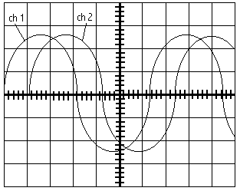

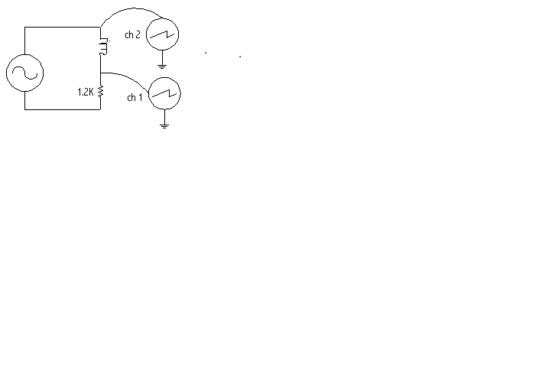

1. The signal seen on channel 1 2. The signal seen on channel 2
Represents the phase of? Represents the phase of?

A. Circuit current A. Circuit current
B. Circuit voltage B. Circuit voltage

3. Determine the following values based upon the scope and circuit information

Phase angle _____________

Impedance _____________ capacitive reactance _________

Frequency ______________ capacitor _________________

4. Band 1 - Orange Resistor Value = ________________
Band 2 - Yellow Tolerance in % = ________________
Band 3 - Red Tolerance in Ohms = _____________
Band 4 - Gold Maximum Resistor Value = _____________
Minimum Resistor Value = _____________

5. Band 1 - Gray Resistor Value = ________________
Band 2 - Blue Tolerance in % = ________________
Band 3 - Red Tolerance in Ohms = _____________
Band 4 - Silver Maximum Resistor Value = _____________
Minimum Resistor Value = _____________

6. Band 1 - Brown Resistor Value = ________________
Band 2 - Black Tolerance in % = ________________
Band 3 - Black Tolerance in Ohms = _____________
Band 4 - None Maximum Resistor Value = _____________
Minimum Resistor Value = _____________

7. Band 1 - Green Resistor Value = ________________
Band 2 - Violet Tolerance in % = ________________
Band 3 - Yellow Tolerance in Ohms = _____________
Band 4 - Gold Maximum Resistor Value = _____________
Minimum Resistor Value = _____________

8. Band 1 - Red Resistor Value = ________________
Band 2 - Yellow Tolerance in % = ________________
Band 3 –Red Tolerance in Ohms = _____________
Band 4 - Gold Maximum Resistor Value = _____________
Minimum Resistor Value = _____________

9. From the scope drawings determine the following values.
Time/cm 20us
Volt/cm 50mV
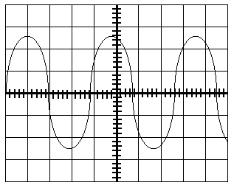

Time __________ frequency __________ Vpp __________ Vp __________ Vrms __________

10. From the scope drawings determine the following values.

Time/cm 2us
Volt/cm 100mV

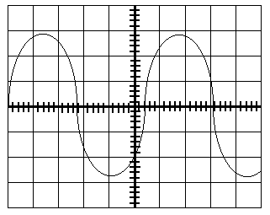
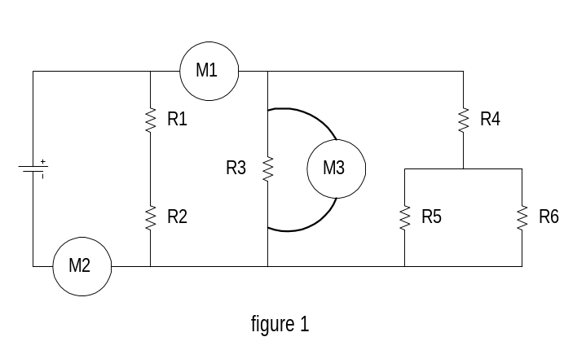
Time __________ frequency __________ Vpp __________ VP __________ Vrms __________

- Using the schematic in figure 1, what is meter 1 ________________________________________
- Using the schematic in figure 1, what is meter 2 measuring? ________________________________

- Using the schematic in figure 1, what is meter 3 measuring? _________________________________

14. From the drawing below answer the following questions.

a. Total current increase / decrease

b. What is the malfunction open / short

c. Define the malfunction _____________________________________________________

d. Knowing the type of malfunction, what will the voltage drops do across the components that do not have a change in resistance increase / decrease

e. Which component’s voltage does not follow the criteria in step d. R1 R2 R3
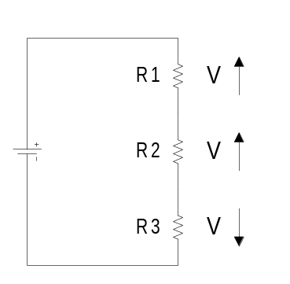

15. From the drawing below answer the following questions.

a. Total current increase / decrease

b. What is the malfunction open / short

c. Define the malfunction _____________________________________________________

d. Knowing the type of malfunction, what will the voltage drops do across the components that do not have a change in resistance increase / decrease

e. Which component’s voltage does not follow the criteria in step d. R1 R2 R3
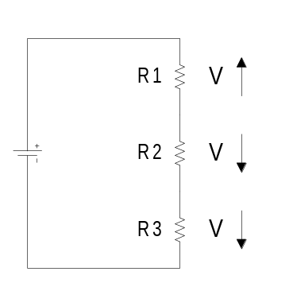

- An open circuit can be described as:

- An increase in resistance that causes an increase in current.
- A decrease in resistance that causes an increase in current.
- A decrease in resistance that causes a decrease in current.
- An increase in resistance that causes a decrease in current.

- A parallel circuit contains two branches. If a third resistor is added in parallel, what will voltage of branch 1 and branch 2 do?

- Go up
- Go down
- Stay the same.
- The current in branch 1 and branch 2 will exactly triple.

- A parallel circuit contains two branches. If a third branch is added to the circuit, the totals circuit current will________.

- Go up
- Stay the same
- Go down
- None of the above are correct.

- An short circuit can be described as:

- An increase in resistance that causes an increase in current.
B. A decrease in resistance that causes an increase in current.
C. A decrease in resistance that causes an increase in current.
D. A decrease in resistance that causes a decrease in current.

- If an additional resistor is added in series, circuit current will:

- increase
- decrease
- no change

